Moon Lander

Program Description

The object of the game is to safely navigate a lunar module to land on a flat portion of the moon's surface. To pilot the lander, horizontal thrusters can be activated to maneuver the ship left and right, and vertical thrusters can be fired to slow its descent.

Design Overview

This program will be separated by many files which will hold 6 objects. The 6 objects will handle the different aspects of the game play. The game will progress through a game loop where it will first handle input from the user, second will advance the game, and third will draw all objects on the screen every frame (loop).

Interface Design

Output

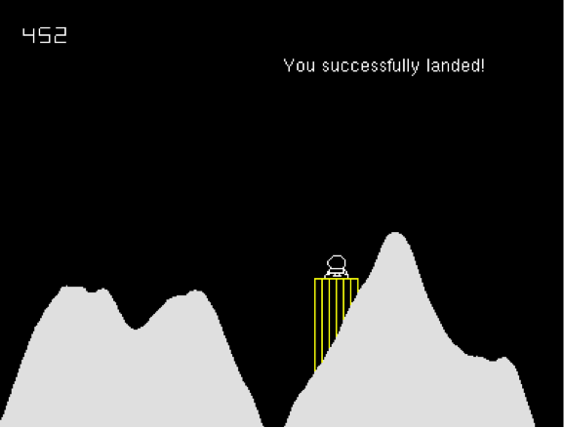

|  |  |
| --- | --- |
| Down Arrow | Moves lander up |
| Right Arrow | Moves lander left |
| Left Arrow | Moves lander right |

Input

Messages

|  |  |
| --- | --- |
| If landed lander | Output “You have successfully landed!” |
| If crashed | Output “You have crashed!” |

Algorithms

applyThrustBottom

add .3 to setDy

subtract 3 from setFuel

applyThrustLeft

add .1 to setDx

subtract 1 from setFuel

applyThrustRight

subtract .1 from setDx

subtract 1 from setFuel

Data Structures

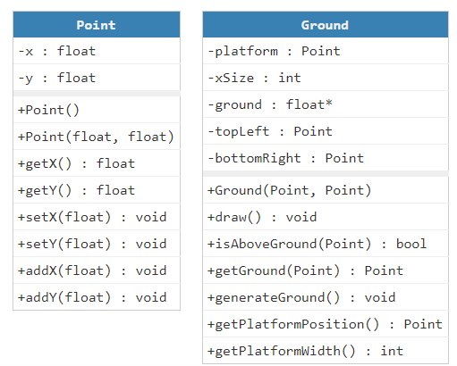

|  |
| --- |
| * point : Point |
| * alive : bool |
| * landed : bool |
| * fuel : int |
| * cThrust : bool |
| + Lander() |
| + getPoint() : Point |
| + getVelocity() : Velocity |
| + isAlive() : bool |
| + isLanded() : bool |
| + getFuel() : int |
| + canThrust() : bool |
| + setLanded(bool) : void |
| + setAlive(bool) : void |
| + setFuel(int) : void |
| + applyGravity(float) : void |
| + applyThrustLeft() : void |
| + applyThrustRight() : void  + applyThrustBottom() : void |
|  |
| + advance() : void |
| + draw() : void |

|  |
| --- |
| * Dx |
| * Dy |
| + Velocity() |
| + Velocity(float, float) |
| + getDx() : float |
| + getDy() : float |
| + setDx(float) : void |
| + setDy(float) : void |

Lander Velocity

File Format

This does not apply to this project

Error Handling

|  |  |  |
| --- | --- | --- |
| Wrong key pressed | Input other than arrows | Does nothing |
| Dx or Dy go out of range | Over 200 or below -200 | Reset back to 200 or -200 |
| Fuel goes below 0 | Variable fuel falls below 0 | Reset fuel to 0 |